NUMBERS 1-10
1. Look at the numbers
one | two | three | four | five
six | seven | eight | nine | ten

How many frogs are there?  RED  GREEN  PURPLE  BLACK  ORANGE  PINK  There are three frogs. | 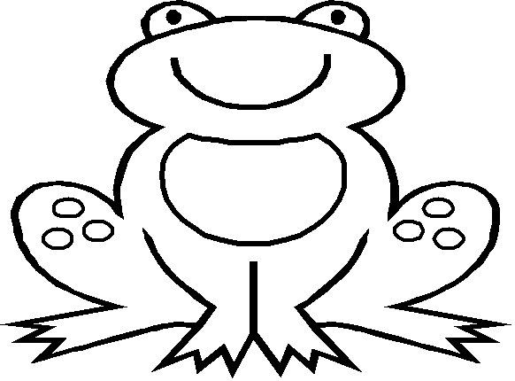

2. Count and write the number.

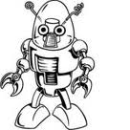 | How many robots are there?  There are _______ robots.

 | How many dolls are there?  There are _______ dolls.

 | How many balls are there?  There are _______ balls.

