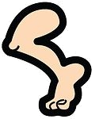
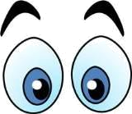
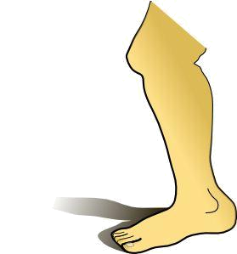
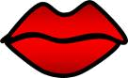
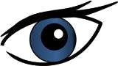
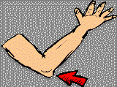
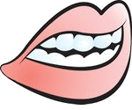
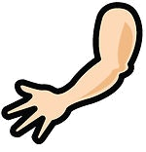
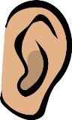
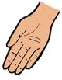
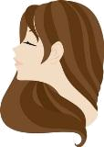
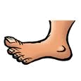
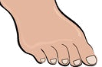
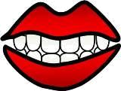
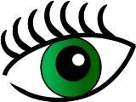
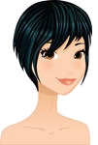
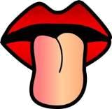
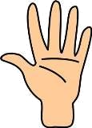
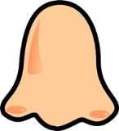
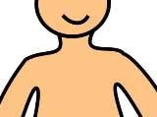
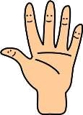
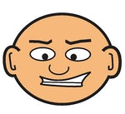
BODY PARTS
2
Match the words to the correct pictures and complete the crossword. Then find a secret message.

1
3
4
5
6
7
8
9
10
11
12
13
14
15
16
17
18
19
20
21
The secret message is _________ _________ ________ ________ ________ _________.
22
4
7
8
10
13
14
15
2
17
18
19
arm
ears
elbow
eyebrows
eyelashes
eyes
finger
foot
forehead
hair
hand
knee
legs
lips
mouth
neck
nose
shoulder
teeth
toes
tongue
wrist

21
22
1
3
6
5
9
11
12
16
20

BODY PARTS
2
Match the words to the correct pictures and complete the crossword. Then find a secret message.

1
3
4
5
6
7
8
9
10
11
12
13
14
15
16
17
18
19
20
21
The secret message is _________ _________ ________ ________ ________ _________.
22
4
7
8
10
13
14
15
2
17
18
19
arm
ears
elbow
eyebrows
eyelashes
eyes
finger
foot
forehead
hair
hand
knee
legs
lips
mouth
neck
nose
shoulder
teeth
toes
tongue
wrist

21
22
1
3
6
5
9
11
12
16
20

BODY PARTS
K
E
E
P
Y
O
U
R
E
A
R
T
O
T
H
E
G
R
O
U
N
N
E
E
E
B
L
2
Y
Match the words to the correct pictures and complete the crossword. Then find a secret message.

1
R
O
G
3
S
I
L
S
4
E
5
E
W
6
B
E
O
7
T
H
M
8
M
9
H
10
N
D
11
O
O
F
T
12
E
13
H
E
E
14
15
16
17
18
19
20
21
S
L
A
E
S
N
C
K
N
O
E
U
I
S
W
N
S
E
H
L
E
D
S
I
R
G
E
The secret message is Keep your ear to the ground.
D
22
A
H
E
R
S
L
A
S
R
A
I
A
H
T
T
T
F
O
4
7
8
10
13
14
15
2
17
18
19
arm
ears
elbow
eyebrows
eyelashes
eyes
finger
foot
forehead
hair
hand
knee
legs
lips
mouth
neck
nose
shoulder
teeth
toes
tongue
wrist

21
22
W
S
S
Y
E
E
R
E
F
O
1
3
6
5
9
11
12
16
20

